NATIONAL UNIVERSITY OF MODERN LANGUAGE ISLAMABAD
Lab 03


Submitted to:
Ms. Saadia Shabbir
Submitted by:
Zulqarnain Hassan (SP21379)
Ehsan Mehmood (SP21371)
Subject: …………………… Web engineering
Department: ……………… BSSE-5-Afternoon
Date: ……………………… 07-10-2024

Q1 Consider any scenario and pick a problem statement and Create at least two HTML pages for references and link the main page to those references. Use necessary and appropriate html commands and commands you have learned so far,use proper File paths to images, proper usage of links, horizontal rules and all basic html commands.
Main page

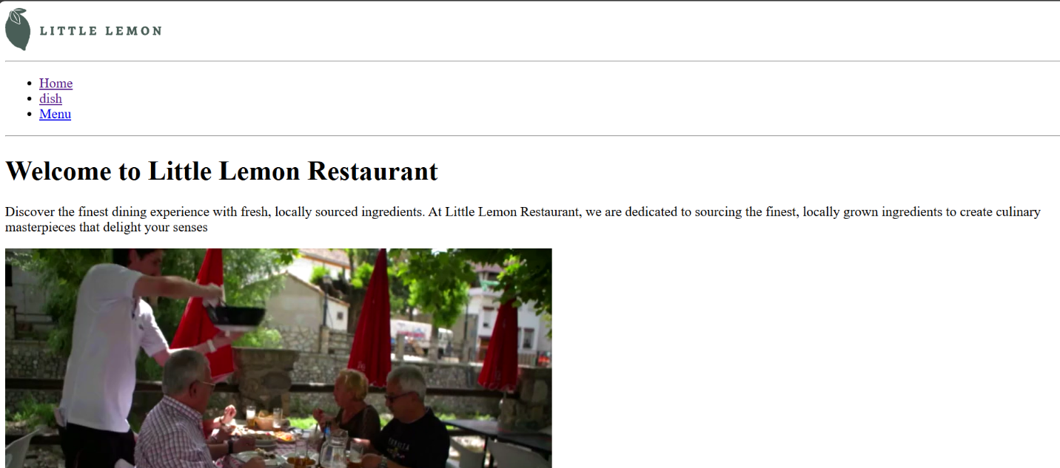

Dishes page

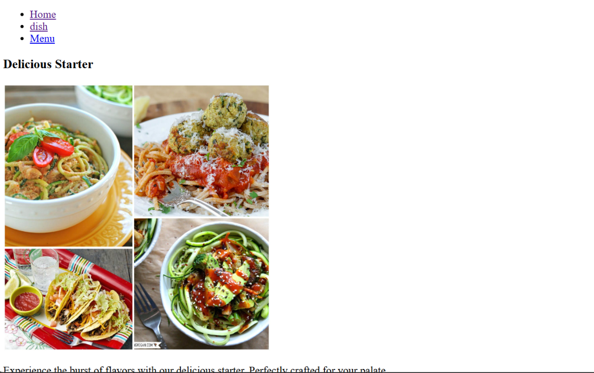

Menu page

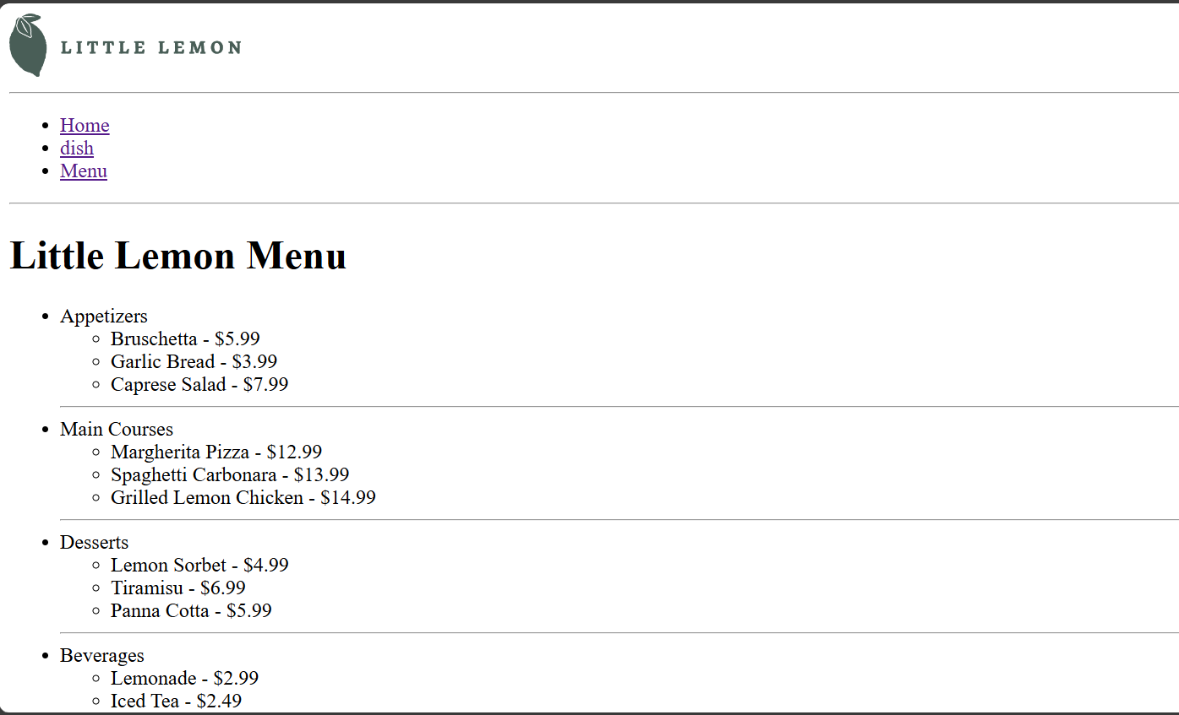

Q2 Consider any scenario and pick a problem statement and create a web page using appropriate file paths and text formatting elements.

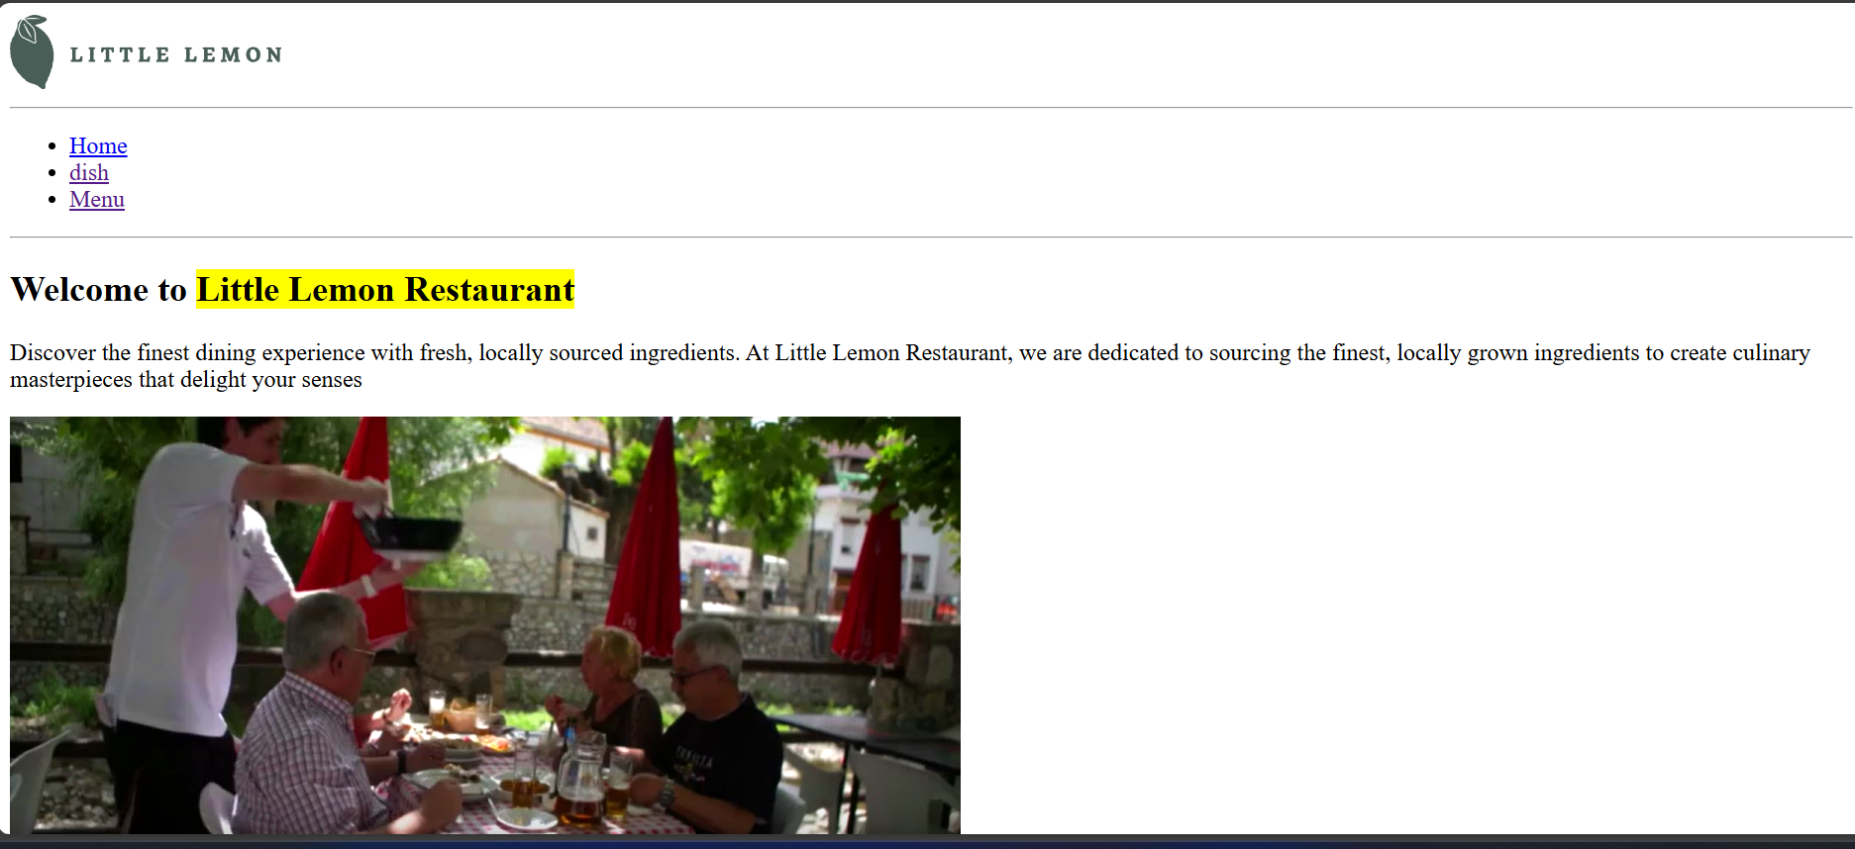

Q3 Explore HTML Emojis from the following link and create a proper web page with all controls learned so far as well as emojis https://www.w3schools.com/html/html_emojis.as